Assignment 9.4

1. Setting Breakpoints in Google Chrome

1. 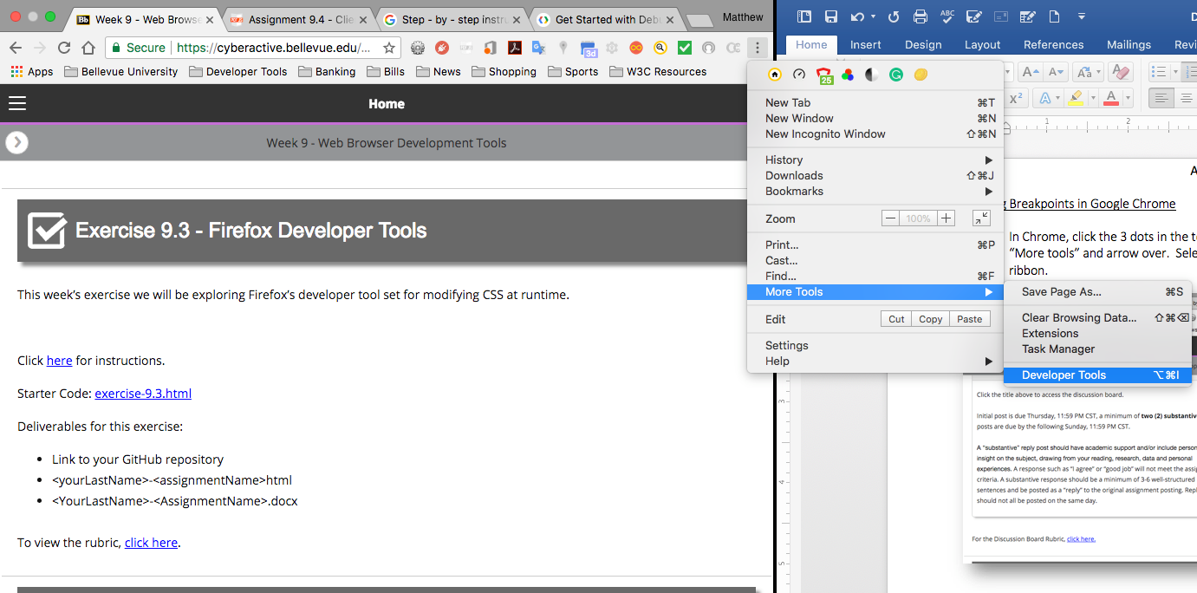In Chrome, click the 3 dots in the top right-hand corner of the window. Scroll down to “More tools” and arrow over. Select “Developer Tools” at the bottom of the menu ribbon.
2. 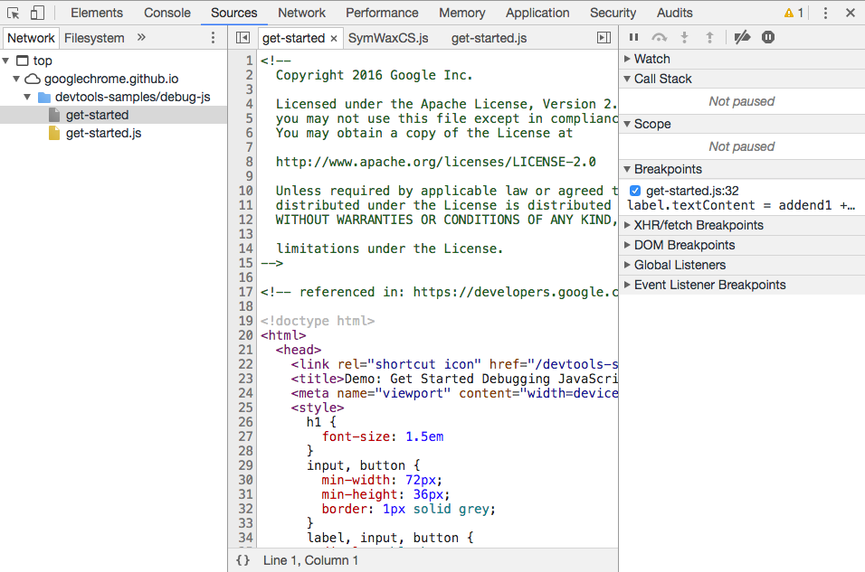Next, select the Sources tab and press Command+P to open the file in the File Navigator.
3. 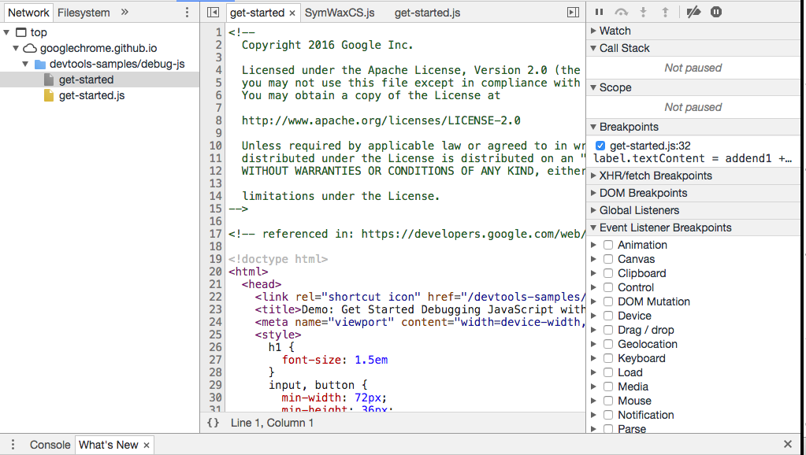Next, you will go to the JavaScript Debugging pane, click the arrow to expand Event Listener Breakpoints.
4. 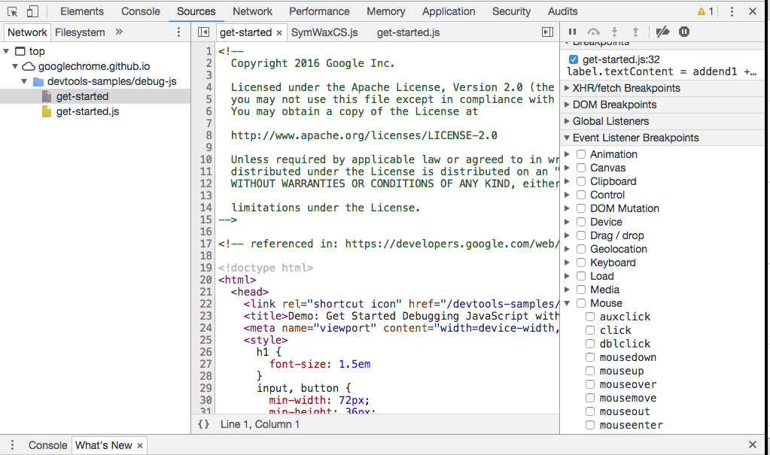Scroll down to Mouse and click the arrow to expand it.
5. 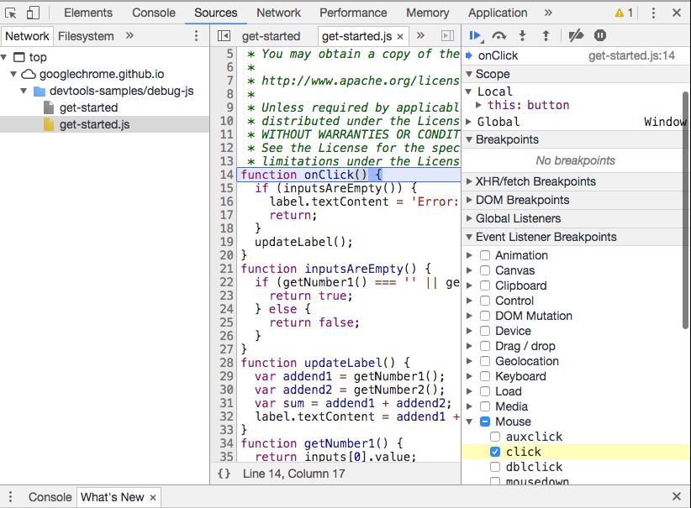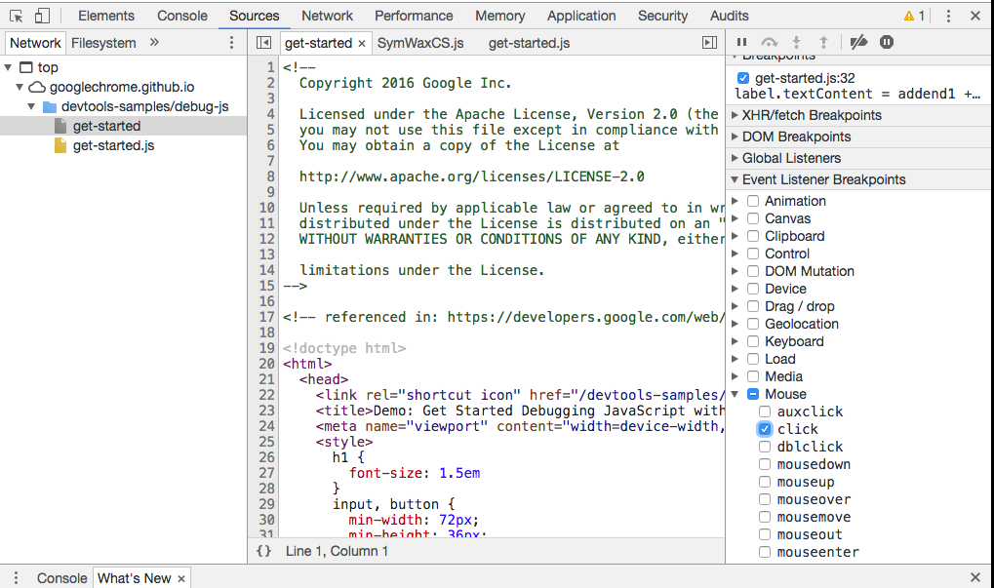Click the box that reads “click”. This should be the only box with a checkmark.
6. Next, re-run your code. function onClick() should be highlighted.
7. 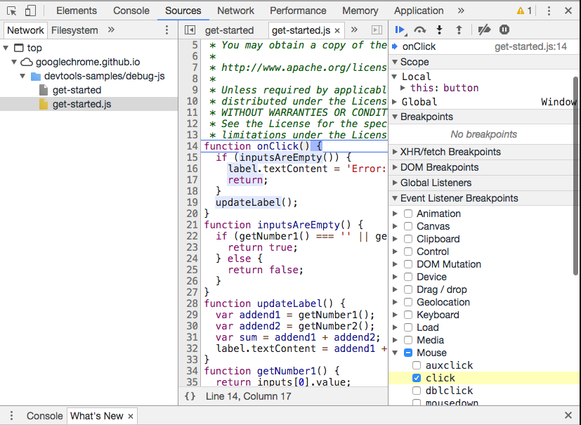Now, on the toolbar in the JavaScript Debugging pane click the down arrow with the dot underneath it. This is the “Step into next function call”. This will run your code line-by-line.
8. 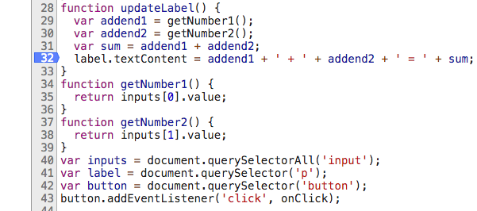Click the line where the error resides.
9. 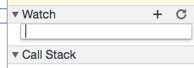Expand the Watch section in the JavaScript Debugger and click the “+”. This will present a text box for you to enter your new statement.
10. After editing your code, save your changes and click Deactivate breakpoint and re-run your page. It should be working correctly.



2. Logging & Reading Messages from the JavaScript Console Window

1. 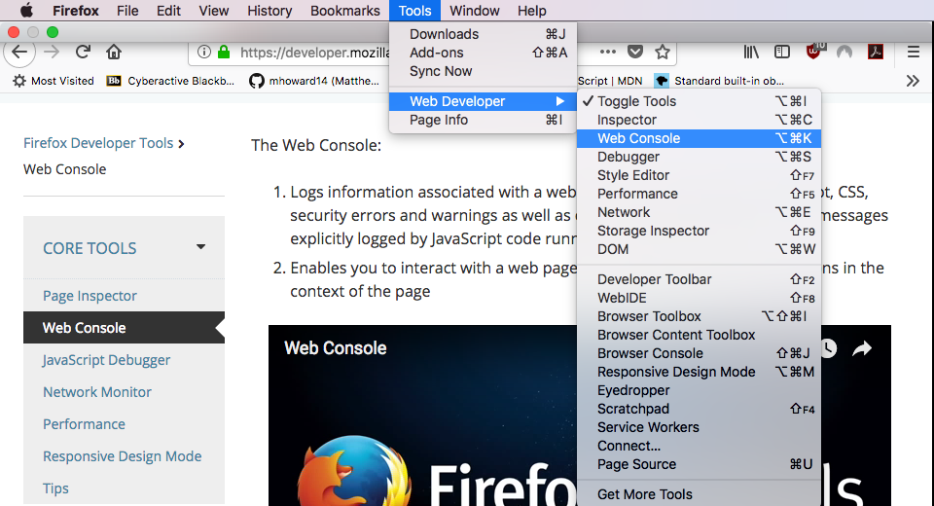First, open the Web Console.
2. This will bring you to the debugger. Errors and warning will have a link next to them.
3. 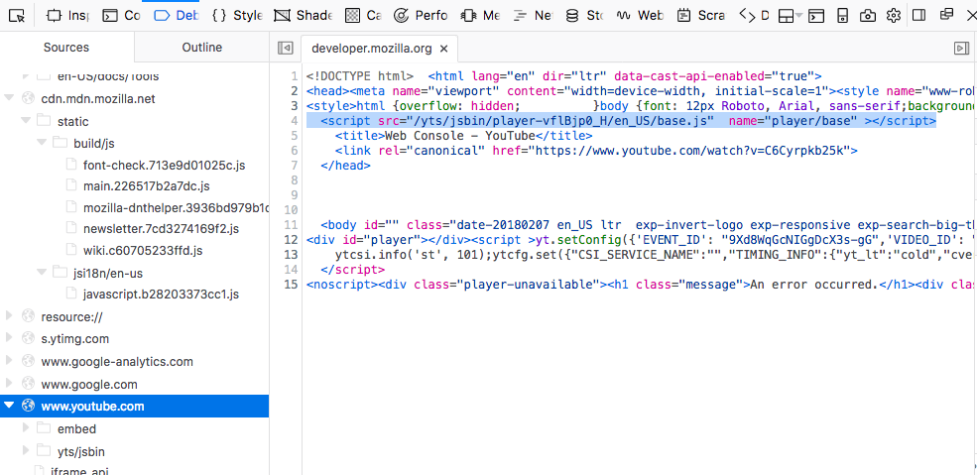Click the link to open the error.

3. How to Select HTML Elements in The JavaScript Console

1. To select HTML Elements in the JavaScript console, you would use the document.getElementById(id).innerHTML = new HTML statement. 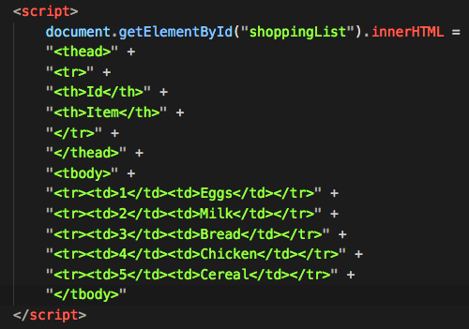
2. You can then make your changes, refresh your webpage and your results will show.  
     
    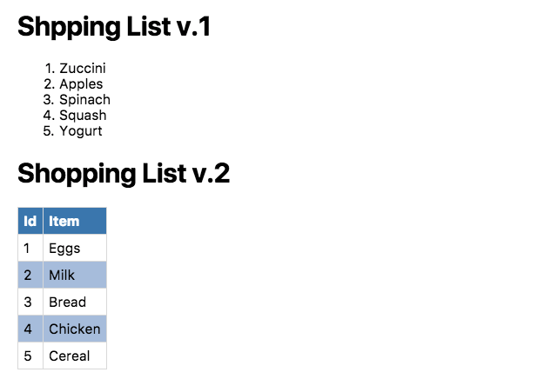

4. How to simulate CSS states (hover, focus) on live HTML elements

1. First, open the DevTools.
2. 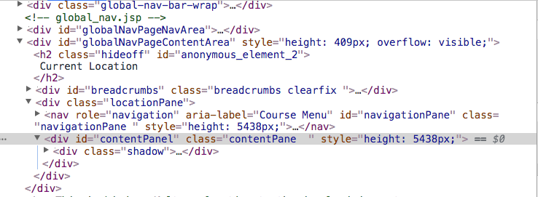Next, select the HTML element you would like the modify.
3. 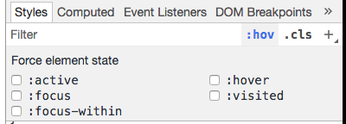 In the Styles, click the :hov and you will see a box drop down with 5 selections.
4. 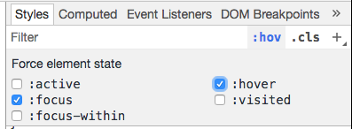 Click the Force Element State that you wish to use.
5. Next, apply whatever changes you wish to the CSS-styling and you’re finished.